MODULE-1
Chemistry of Electronic Materials

Conductors and Insulators
Conductors
Definition and Principle:
Conductors are the materials or substances which allow electricity to flow through them. They conduct electricity because they allow electrons to flow easily inside them from atom to atom. Also, conductors allow the transmission of heat or light from one source to another.
Conductors have free electrons on its surface which allow current to pass through easily. This is the reason why conductors are able to conduct electricity.
Example: Copper, Aluminum, Gold, and Silver etc

Insulators
Definition and Principle:
Insulators are the materials or substances which resist or don’t allow the current to flow through them.
In general, they are solid in nature. Also, insulators are finding use in a variety of systems. As they do not allow the flow of heat.
The property which makes insulators different from conductors is its resistivity.
Wood, cloth, glass, mica, and quartz are some good examples of insulators. Also, insulators are protectors. They give protection against heat, sound and of course passage of electricity. Furthermore, insulators don’t have any free electrons. It is the main reason why they don’t conduct electricity.
Example: Glass, Plastic, Rubber, and Wood etc
Semiconductors
Semiconductors are materials which have conductivity between conductors and nonconductors or insulators.
Semiconductors can be pure elements, such as silicon or germanium, or compounds such as gallium arsenide or cadmium selenide.

Band theory and conductors, insulators and semi-conductors
Conductors:
- In a conductor there are no band gaps between the valence and conduction bands. In some metals the conduction and valence bands partially overlap. This means that electrons can move freely between the valence band and the conduction band
- The conduction band is only partially filled. This means there are spaces for electrons to move into. When electrons for the valence band move into the conduction band they are free to move. This allows conduction

Insulators:
- An insulator has a large gap between the valence band and the conduction band.
- The valence band is full as no electrons can move up to the conduction band. As a result, the conduction band is empty.
- Only the electrons in a conduction band can move easily, so because there aren't any electrons in an insulator's conduction band, the material can't conduct
Semiconductors:
- In a semiconductor, the gap between the valence band and conduction band is smaller. At room temperature there is sufficient energy available to move some electrons from the valence band into the conduction band. This allows some conduction to take place.
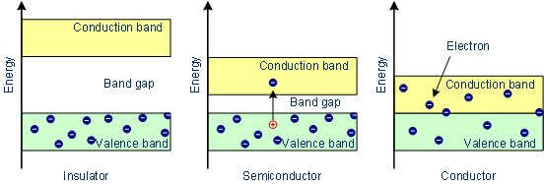
- An increase in temperature increases the conductivity of a semiconductor because more electrons will have enough energy to move into the conduction band.

Production of electronic grade Silicon-Czochralski process (CZ)
In this method a single crystal is used as seed. When this seed is used to grow single crystals from Polycrystalline silicon, the atoms of Polycrystalline silicon reproduce the same arrangement as in the seed. Thus a single crystal of silicon is produced from polycrystal.
Calculated amount of dopant is added to Polycrystalline silicon. It is taken in quartz chamber and heated using RF power source in an atmosphere of Argon. When material melts, the temp is lowered so that it is kept at Melting point of the material. A single crystal of silicon is attached to the tip of the Puller rod and is lowered into the molten material so that it just touches the surface of the material. The rod is slowly rotated and simultaneously pulled out. As the melt is pulled out, it solidifies and has the same orientation and crystal structure as in the seed. The pull rate is maintained at 1.5 to 5 cm per hour and the rotation is about 100 rpm (rotation per minute).

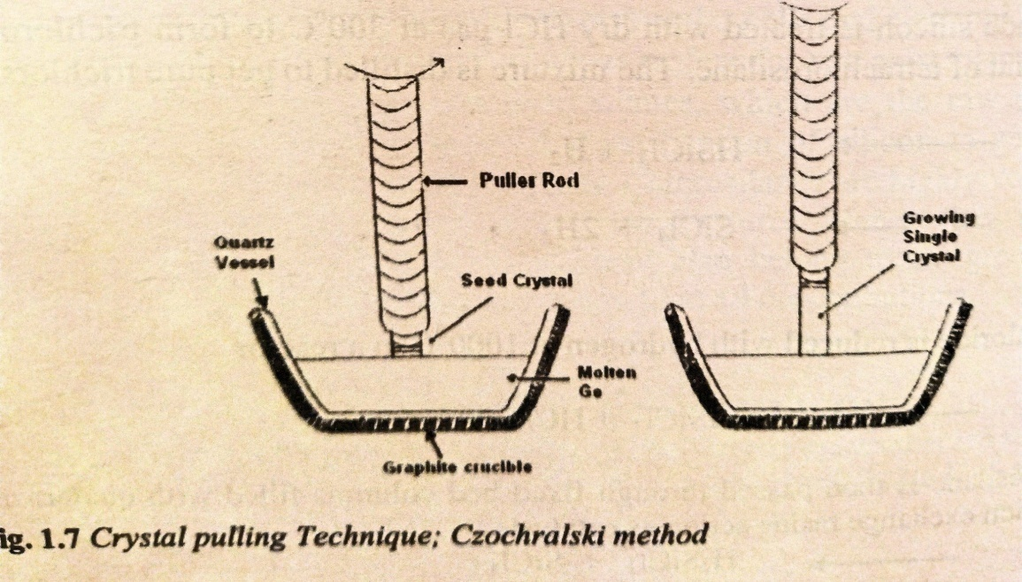

Production of electronic grade Silicon- Float Zone (FZ) methods.

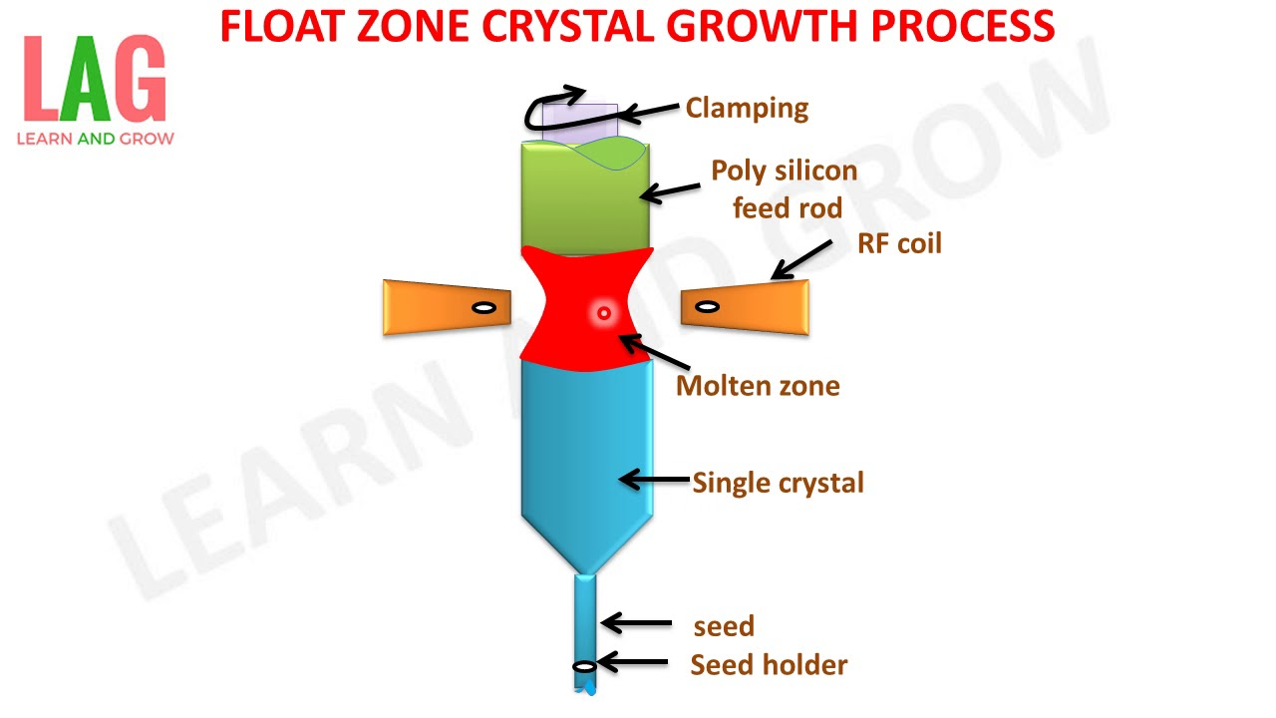

A polycrystalline rod of ultrapure electronic-grade silicon is passed through an RF heating coil, which creates a localized molten zone from which the crystal ingot grows. A seed crystal is used at one end to start the growth. The whole process is carried out in an evacuated chamber or in an inert gas purge.

Polymers
Definition:“Polymers are macro sized molecules of high molecular mass formed by the combination of a large number of simple molecules by covalent bonds”.
Ex: Polyethylene, polyacetylene, polystyrene, polyvinyl chloride, natural and synthetic rubbersetc.
Monomer: Is a simple molecule having two or more bonding sides
Ex: Vinyl chloride, ethylene etc,
Polymerization:“The process by which the monomers are converted into polymers is called Polymerization”.
Types of Polymerization:
Polymerization is of two types.
1) Addition polymerization (chain polymerization):
It is a process in which number of simple monomers joining together by chain reaction without the elimination of any byproducts.
Ex: a) Preparation of polyethylene from ethylene

2) Condensation polymerization (step polymerization):
A polymerization reaction in which bi-functional monomers undergoes condensation with continuous elimination of byproducts such as H₂O, NH₃, HCl, etc is called condensation polymerization.
Ex: a) Preparation of nylon 6:6 from hexamethylenediamineand Adipic acid.

Molecular Weight of Polymers:
Due to the varying chain lengths, a polymer is considered to have average molecular mass. 2 types of average molecular masses have been recognized namely, number average and weight average molecular masses.
Number average molecular mass: It is obtained by dividing the total weight of the monomers with the number of monomer molecules present in polymer i.e.,
$$\overline{M_{n}} = \frac{n_{1}M_{1}+n_{2}M_{2}+n_{3}M_{3}}{n_{1}+n_{2}+n_{3}}$$
Where n₁, n₂, n₃ are the number of molecules having masses M₁, M₂, M₃ respectively. The above equation can also be written as, $\overline{M_{n}}=\frac{\sum{niMi}}{\sum{ni}}$
Where M_{i} is the masses of monomers and n_{i} is the number of monomers.
Weight average molecular mass: It gives the representation to different molecular species in proportion to their weight in the given polymer molecule.
$$\overline{M_{w}} = \frac{n_{1}M_{1}2+n_{2}M_{2}2+n_{3}M_{3}2}{n1M1+n2M2+n3M3}$$

Where w and M represent the weight and molecular masses of each species present in polymers. Since w= nM, $=\frac{\sum{{niMi}^{2}}}{{\sum{niMi}}^{}}$
Polydispersity of Polymer:
Of a Polymer is either equal to or greater than its $\overline{{ M}_{n}}$ . And hence /$\overline{{ M}_{n}}$ is greater than or equal to 1. The deviation from unity of this ratio is referred to as distribution ratio which is a measure of Polydispersity of Polymer. A higher vaule indicates greater polydispersity.
Numerical Problems:
A Polymer sample contain 6 molecules having molecular weight of 1000, 5 molecules having molecular weight of 2000 and 4 molecules having molecular weight of 3000. Calcuate Number average and Weight average molecular weight.
Ans: W.K.T
$$\overline{M_{n}} = \frac{n_{1}M_{1}+n_{2}M_{2}+n_{3}M_{3}}{n_{1}+n_{2}+n_{3}}$$$\overline{{ M}_{n}}$ = 6 X 1000 + 5X2000 +4X3000
6+5+4

$\overline{M_{n}}$= 6000 +10000 +12000
15

$\overline{M_{n}}=$1866.66

$$\overline{M_{w}} = \frac{n_{1}M_{1}2+n_{2}M_{2}2+n_{3}M_{3}2}{n1M1+n2M2+n3M3}$$

$\overline{M_{w }}$ = 6(1000)² +5 (2000)² + 4(3000)²
6X1000 +5X2000 + 4X30000

$\overline{M_{w }}$ = 60,00,000 +20000000 + 36000000
6000 +10000 +12000

$\overline{M_{w }}$ = 62000000
28000
$\overline{M_{w }}$ = 2214.28

CONDUCTING POLYMERS

Definition: “An organic polymer with highly delocalized pi-electron system having electrical conductance of order of a conductor is called conducting polymer”.
Ex: Polyacetylene, polypyrrole, polythiophene, polyphenylene, polyaniline, etc.

Synthesis and Conducting mechanism of Polyacetylene
Structure of Polyacetylene [C2H2]n

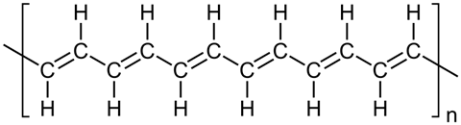

Synthesis:
Polyacetylene can be synthesized using the Zeigler – Natta Catalyst. The Catalyst Tetrabutoxy titanium and triethyl aluminum suspended in silicone oil, through which acetylene is passed, is stirred for 2 hrs at 120⁰ C and then cooled slowly to room temp. Resulting in thin sheet of Polyacetylene.

n (CH ≡ CH)
Zeigler – Natta Catalyst

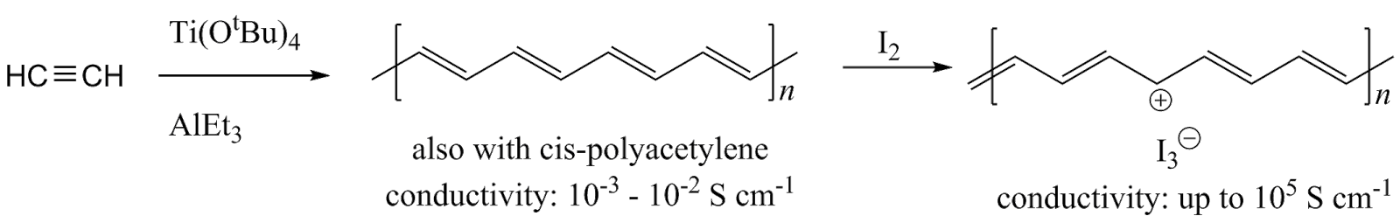

Mechanism of conduction in Polyacetylene

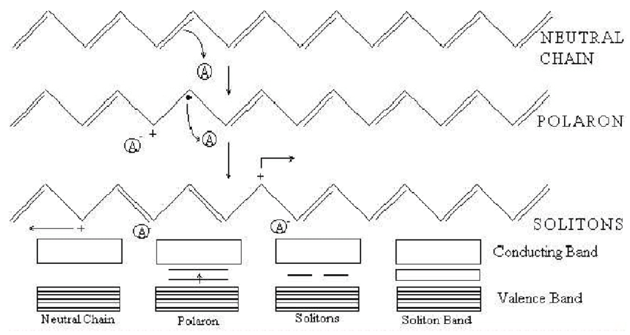

The conductivity of these polymers is believed to be a result of the creation of charge-transfer complexes between the polymer and halogen. Charge transfer occurs from the polymer to the acceptor compound; the polyacetylene chain acts as a cation and the acceptor as an anion.

Commercial applications

- Used as light weight electrodes for rechargeable batteries
- Used as Corrosion resistance paints
- Used gas sensors, radiation and thermal sensor
- Used as information storage device and capacitors

Preparation, properties and commercial applications of Graphene oxide
Preparation:
Graphene oxide was synthesized by Hummers method through oxidation of graphite. The stepwise preparation is given as follows:
- Graphite flakes (2 g) and NaNO3 (2 g) were mixed in 50 mL of H2SO4 (98%) in a 1000 mL volumetric flask kept under at ice bath (0-5°C) with continuous stirring.
(It is artificially created by treating graphite with strong oxidisers such as sulphuric acid. These oxidisers work by reacting with the graphite and removing an electron in the chemical reaction.)
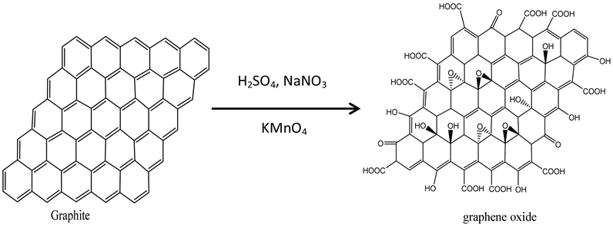
The most outstanding properties of Graphene Oxide are

- Form: Powder.
- Odor: Odorless.
- Sheet dimension: Variable.
- Solubility: Insoluble
- Hydrophilic due to the presence of polar functional groups
- Exhibits tunable electrical and optical properties
- Exhibits high specific surface area
Commercial Applications of Graphene Oxide.

- Used in electronic devices
- Energy storage devices,
- (bio)sensors, biomedical applications,
- Supercapacitors, membranes,
- catalysts, and
- Water purification.

ELECTROLESS PLATING
Def^{n}:-Electroless plating is a method of depositing a metal over a substrate by controlled chemical reduction of metal ions by a suitable reducing agent without using electrical energy.
Metal ions + reducing agent → Metal + oxidized product.

Advantages of electroless plating:
- Electrical equipment is not required.
- Semiconductors and insulators can also be plated.
- Electroless plating baths have better throwing power.
- Electroless coatings are harder than the electrodeposited coatings.

Electroless plating of copper in the manufacture of double-sided PCB.
Pretreatment:
Before electroless plating, the surface is cleaned thoroughly. Insulators such as plastics and printed circuit boards are activated by dipping first in stannous chloride (SnCl₂) and then in palladium chloride (PdCl₂). Then, the electroless plating is done under the following conditions:
Bath Composition: 1. Metal in silution - CuSO₄ (12g/ L)
2. Reducing agent : Formaldehyde (HCHO) 8 g/ L
3. Buffer: Sodium hydroxide (15 g/L) and Rochelle salt 14 g/L
(Na-K- tartrate)
4. Complexing agent: EDTA 20g/ L
5. pH: 11 & Temperature :25 ºC

Reactions:
Manufacture of double-sided PCB
- Through hole connections are necessary when double sided printed circuit boards are fabricated.
- The electrical connection between two sides of the boards are fabricated.
- The electrical connections between two sides of board are made by• drilling hole and the plating through holes by electroless plating.
- For the manufacture of double sided printed circuit boards, the plastic board is initially covered with copper with an etch-resistant pattern of the circuit or the tracking required on both the sides.
- On etching with suitable etchant the copper except below the printed• pattern is etched away, leaving the circuit pattern.
- The connection between two sides is made by drilling hole followed by• activation and plating through holes by electroless plating. The steps involved in the process is shown below fig.

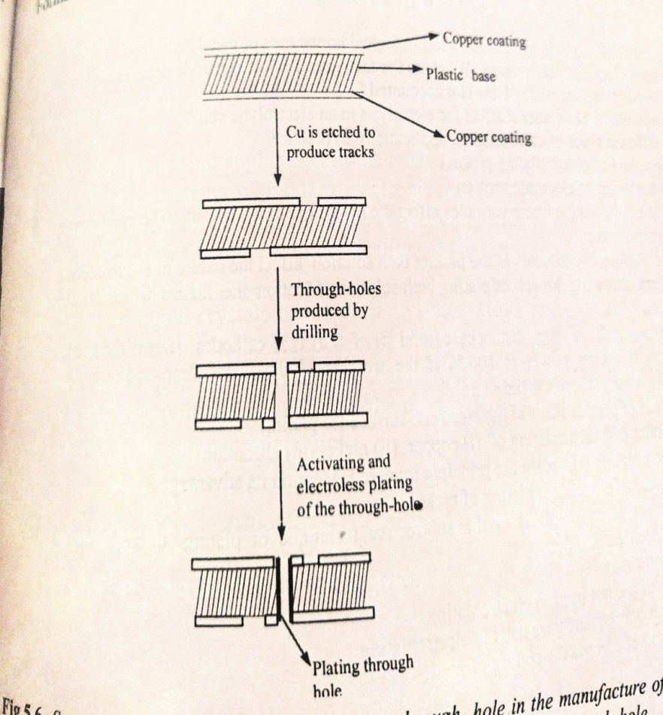

MOST REPEATED QUESTIONS IN VTU EXAM
1) What are conductors and insulators? Explain the principle involved in conductors and insulators by taking an examples. (6 marks)
2) Mention the differences between conductors, semiconductors and insulators band theory? 6marks
3) What are semiconductors? Explain the production of electronic grade silicon by Czochralski (CZ) process. (7 marks )
4) Explain the production of electronic grade silicon by Float Zone (FZ) method. (7marks)
5) What are conducting polymers? Explain the synthesis and conducting mechanism of polyacetylene. Mention its commercial applications. (7marks)
6) Explain the preparation, properties and commercial applications of graphene oxide (Hammer method)? (7 marks)
7) Define electroless plating. Describe the electroless plating of copper in the manufacture of double-sided PCB? (6 marks)
8. Numerical problems on Number average and Weight average molecular weight of polymers. (Refer class notes and Text book) (7 Marks)

